E-LEARNING USER MANUAL

**Version 1.0**

**Index**

**1 Introduction**

**1.1 Purpose of the E-Learning Platform**

**1.2 User Roles**

**1.3 Scope of the User Manual**

**2 Terminology**

**3 Student Module**

**3.1 User Authentication and Dashboard**

**3.2 Course Selection**

**3.3 Assessment**

**3.4 Content Access**

**4 Teacher Module**

**4.1 User Authentication and Dashboard**

**4.2 Content Management**

**4.3 Progress Tracking**

**5 Conclusion**

**5.1 Empowering Learning Journeys**

**5.2 Streamlined Course Management**

**5.3 Emphasis on User Experience**

1. **Introduction**

Welcome to the E-Learning Platform User Manual. This guide is designed to help users navigate and make the most of the features available in the E-Learning platform. Whether you are a student or a teacher, this manual provides step-by-step instructions on how to use various functionalities to enhance your online learning or teaching experience.

* 1. **Purpose of the E-Learning Platform**

The E-Learning Platform aims to provide an interactive and user-friendly environment for both students and teachers. Students can access educational content, track their progress, and engage with assessments, while teachers can manage courses, upload content, and assess student performance.

* 1. **User Roles**

The platform supports two primary user roles:

* Student: Individuals enrolled in courses, accessing educational content, and tracking their progress.
* Teacher: Instructors responsible for creating and managing courses, uploading content, and assessing student performance.
  1. **Scope of the User Manual**

This user manual covers the main functionalities of the E-Learning platform, including user authentication, course management, module progress tracking, content delivery, and assessment management. It is intended for users of version 1.0 of the platform.

1. **Terminology**

Before we explore the various functionalities of the E-Learning platform, let's familiarize ourselves with key terms used throughout this user manual.

**User Authentication:**

Username: The unique identifier chosen by a user for login.

Password: A secret combination of characters used for user authentication.

**Dashboard:**

Overview: The main screen displaying essential information and navigation options.

Video: A multimedia content element providing visual information.

**Course Selection:**

Browse Courses: Exploring available educational programs.

Course: A structured program of study.

Level: The difficulty or complexity level of a course.

Topics: Specific subjects covered within a course.

**Assessment:**

Access Assessments: Entering evaluations at the end of each module.

Submit Button: A control element to finalize and submit assessment answers.

Retake Option: The ability to redo an assessment after reviewing results.

**Content Access:**

Module Navigation: Navigating through educational content within specific modules.

**Content Management (for Teachers):**

Upload Educational Content: Adding educational materials such as topics, videos, and quizzes.

Create Assessments: Generating evaluation materials within modules.

**Progress Tracking (for Teachers):**

Progress Page: A display showing the advancement of each student.

Completed: Indicates if individual subject contents are finished.

These terms provide a foundation for users to understand and navigate the features of the E-Learning platform. Understanding these terms will facilitate your interaction with the E-Learning platform. Now, let's delve into each section's functionalities.

**3 Student Module**

**3.1 User Authentication and Dashboard**

**User Authentication**

Login: Students can log in using their unique username and password.

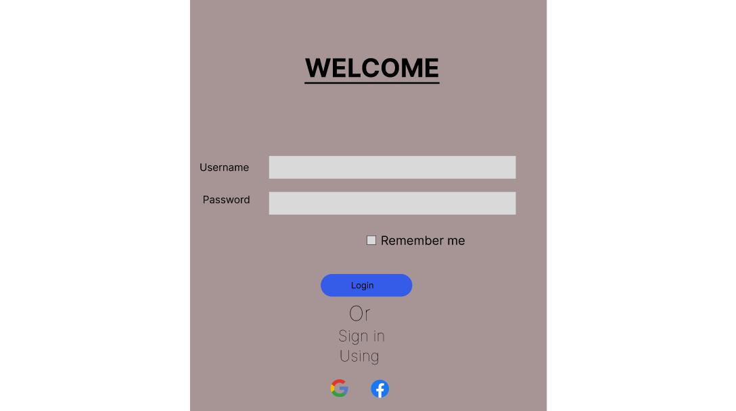

**Dashboard**

Overview: Upon login, students are greeted with a dashboard displaying a video and then navigating to the courses webpage on clicking the start button.

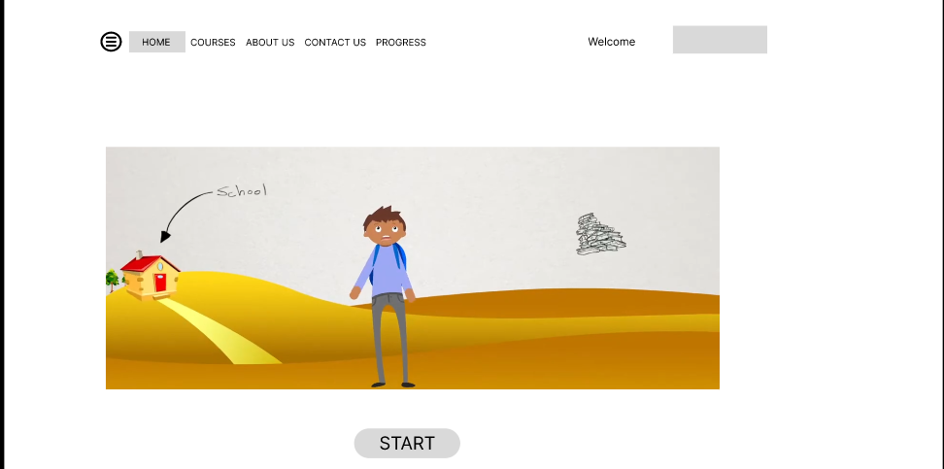

**3.2 Course Selection**

Browse Courses: Students can explore available courses and then select the levels of each course and the topic that he/she want to learn, which then navigates to a video page

Course: 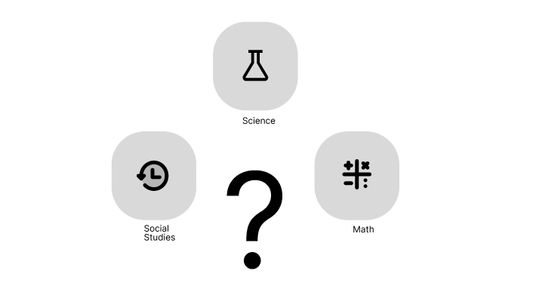

Level: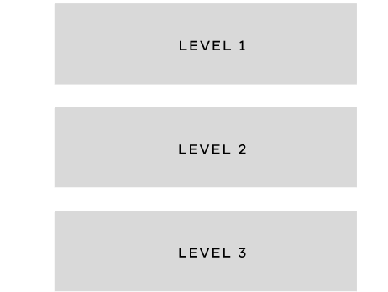

Topics: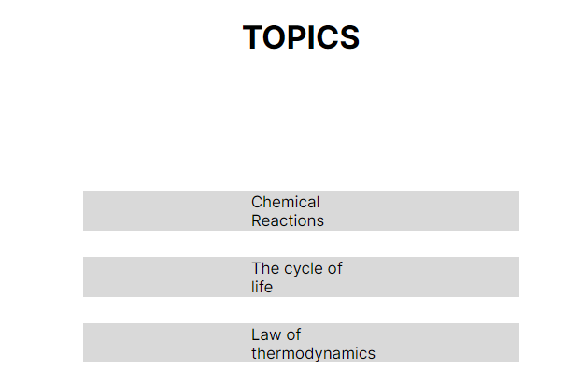

**3.3 Assessment**

Access Assessments: Assessments are available at the end of each module.

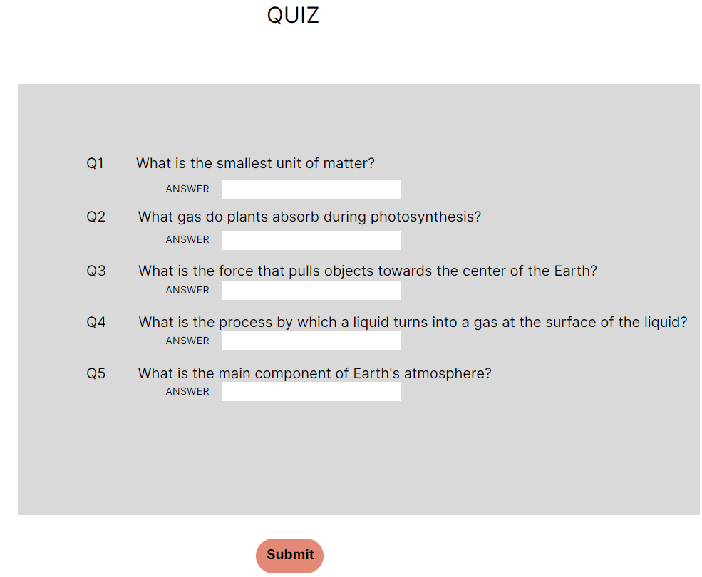

The student can simply enter the answers for each of the question and then hit the submit button, which would then land them to the results page.

Retake Option: Students can retake assessments .

After the assessment is taken by the student, it will land them to the results page and if the student is not satisfied the results he/she can retake the assessment by clicking the retake button at the bottom of the results window.

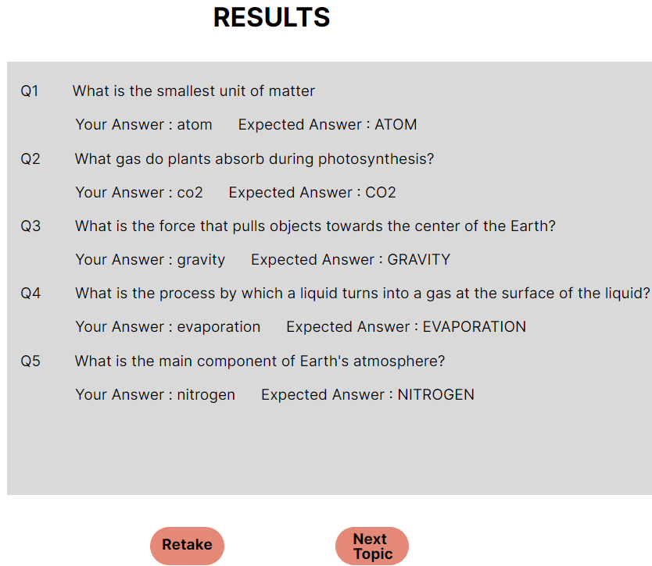

**3.4 Content Access**

Access Educational Materials: Students can access course-related content, including videos and presentations.

Video:

Module Navigation: Intuitive navigation allows easy access to educational materials within specific modules.Anytime the student can go back to the course and select the next course he/she intends to do.



‘

**4 Teacher Module**

**4.1 User Authentication and Dashboard**

User Authentication

Login: Teachers can log in using their unique username and password.

1. Open the eLearning teacher module login screen.
2. Enter your username in the Username field.
3. Enter your password in the Password field.
4. Click the Login button.

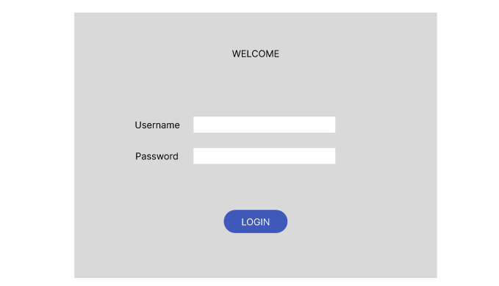

**Dashboard**

**Overview: Upon login, teachers access a dashboard**

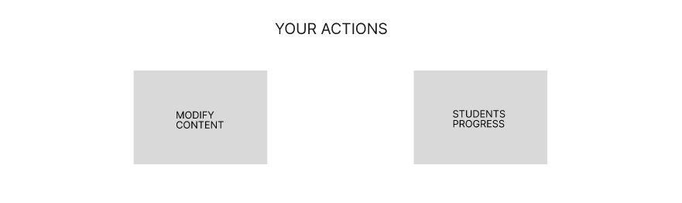

This is the view of the dashboard upon teachers login. And it allows the teachers to select the action he/she intends to do.

**4.2 Content Management**

* Upload Educational Content: Teachers can upload the topics ,videos and the quiz content, which can be accessed by the student in the course content of the student .
* Create Assessments: Teachers can create assessments within modules, specifying questions and correct answers.

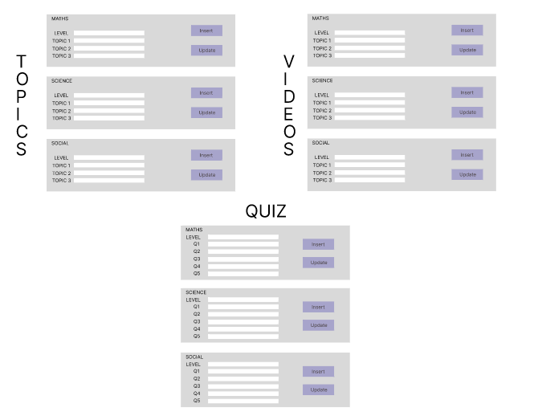

This is the view of the Modify content webpage and allows the teacher to enter the content that would be reflected in the students webpage. The teacher can simply enter the values in the input for each of the content that he/she intends to change or add, and then click the insert option if the teacher wants to add a new content or update if they want to modify and existing content.

**4.3 Progress Tracking:**

This is Students progress page content that displays the progress of each student enrolled with the Elearning and display the progress of each student and mentions if the individual subject contents are completed or not

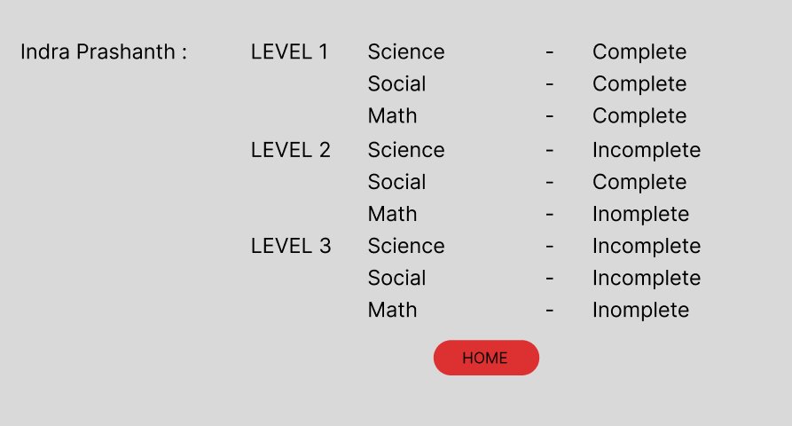

**5. Conclusion**

The E-Learning platform is a comprehensive and user-friendly solution designed to revolutionize the educational experience for both students and teachers. With a robust set of features, the platform facilitates seamless interaction, progress tracking, and content delivery. As we conclude this user manual, let's reflect on the key aspects of the E-Learning platform:

5.1 Empowering Learning Journeys

The platform empowers students to take charge of their learning journeys. Through intuitive interfaces and engaging content, students can navigate courses, track progress, and demonstrate their understanding through assessments.

5.2 Streamlined Course Management

Teachers benefit from streamlined course and module management functionalities. From creating courses and modules to tracking student progress and managing assessments, the platform provides a comprehensive toolkit for educators.

5.3 Emphasis on User Experience

User experience is at the forefront of the platform's design. The interface adheres to accessibility guidelines, ensuring inclusivity. The age-appropriate design caters to the unique needs of 5th-grade students, fostering an environment that is both educational and enjoyable.

In conclusion, the E-Learning platform stands as a testament to our commitment to innovation in education. It is our hope that this platform contributes significantly to the educational landscape, providing an enriching experience for students and facilitating effective teaching for educators. As we embark on this educational journey together, we welcome feedback, suggestions, and a collaborative spirit toward making learning accessible, engaging, and impactful.

Thank you for choosing the E-Learning platform. Happy learning!